**EXPERIMENT 3**

**Name : Urvashi**

**SAP ID : 500083262**

**AIM: Working with Docker Volume**

Steps to Complete:

1. View all Volume in Docker

**Command : docker volume ls**

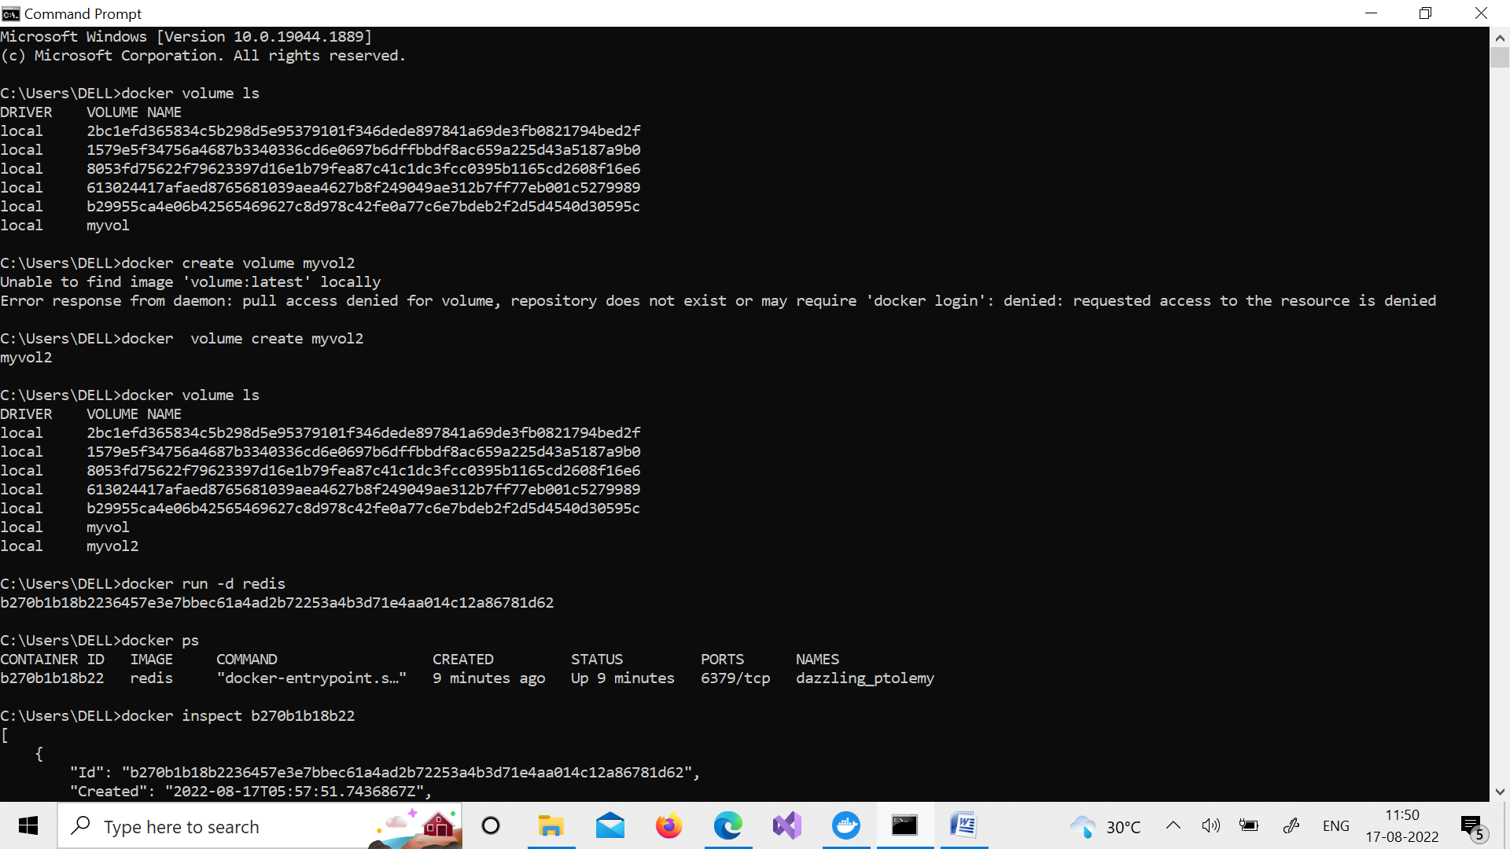

1. Create a new Volume

**Command : docker volume create myvol2**

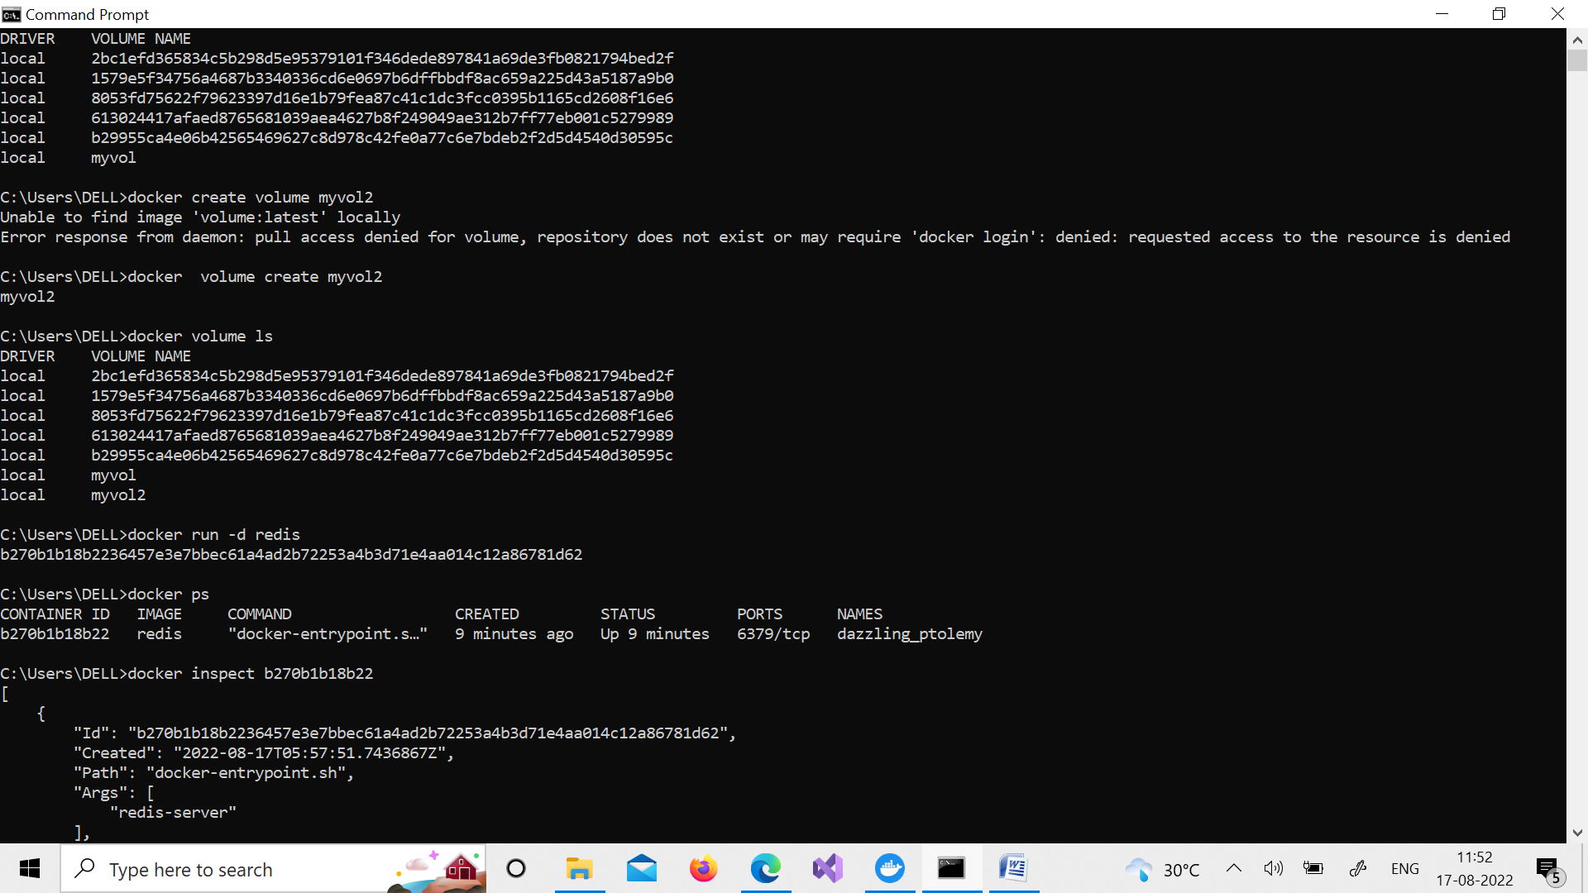

1. Mount a Volume with a container

**Command : docker run –it –v myvol2:/data redis /bin/bash**

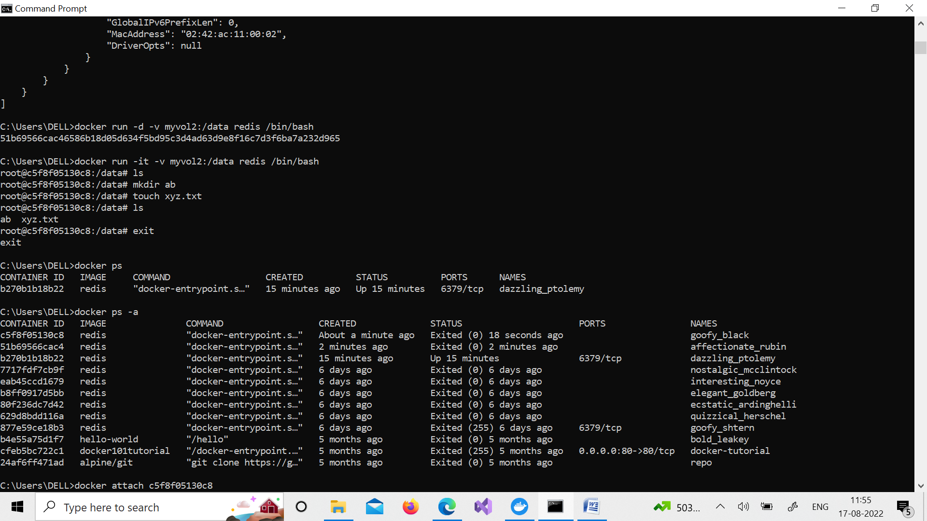

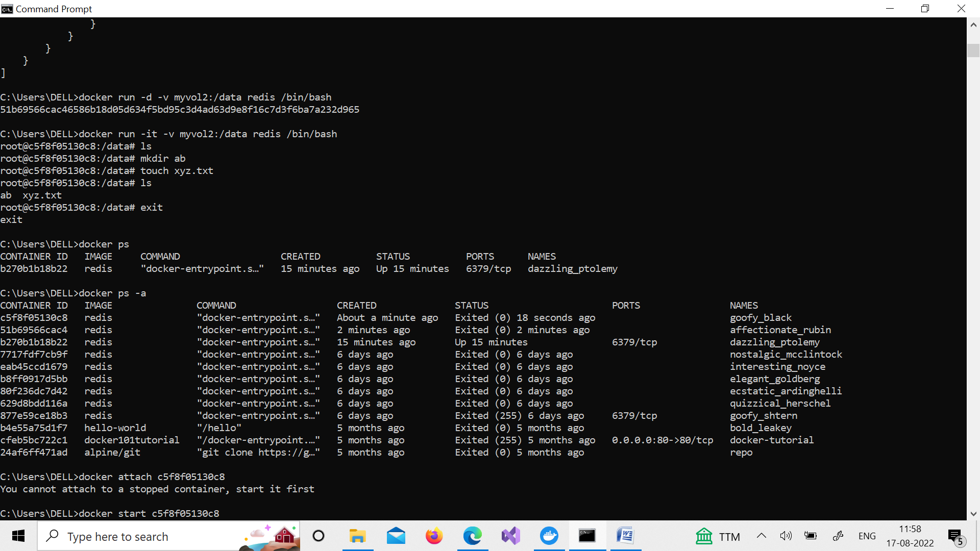

1. Create another container and Mount with the same Volume

**Command : docker run –it –v myvol2:/data redis /bin/bash**



1. See the complete working of container



6. Exited from container and restart again to see the persistent of Docker

**Command : docker start c5f8f05130c8**

**docker attach c5f8f05130c8**

